SPRINT – 1

|  |  |
| --- | --- |
| **Team ID** | **PNT2022TMID29836** |
| **Project Name** | **Customer Care Registry** |

RUNNING WITH PYTHON FLASK:

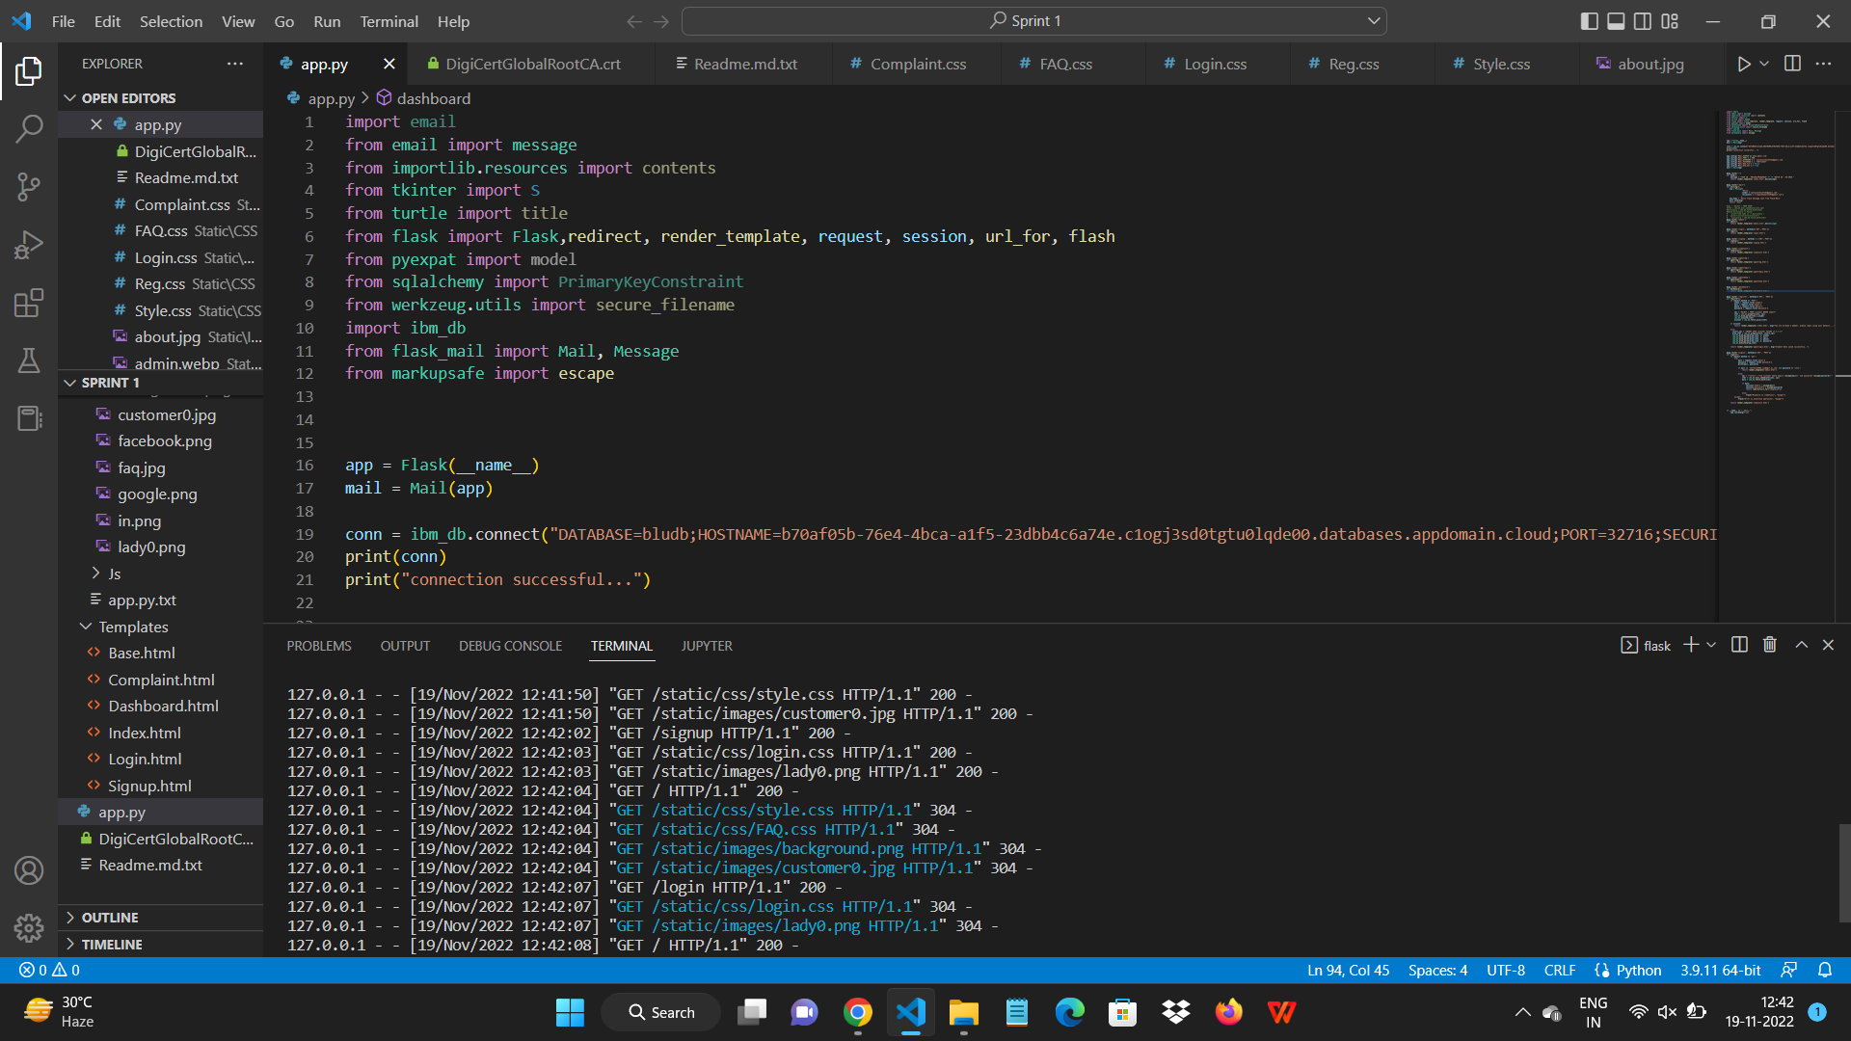

INDEX PAGE:

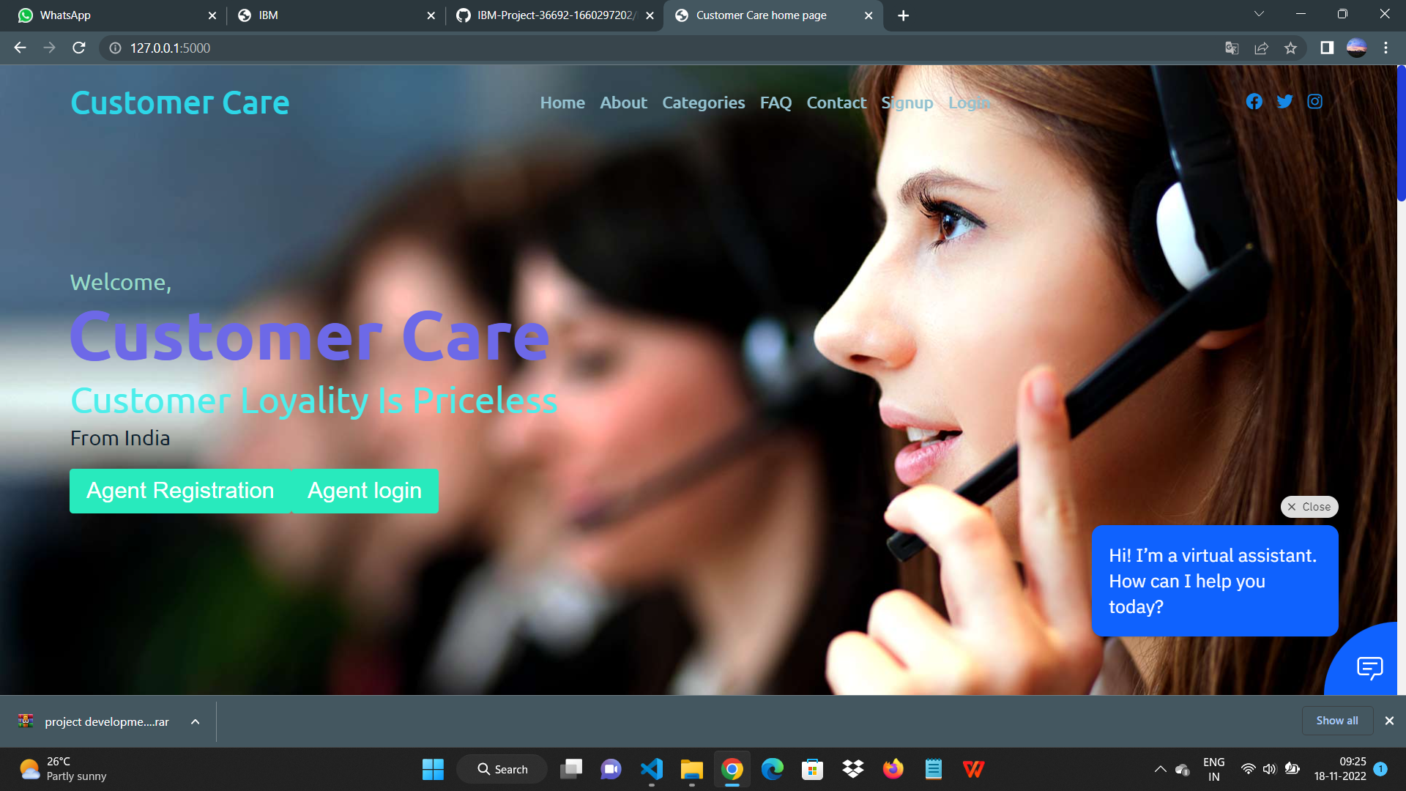

ABOUT US PAGE:

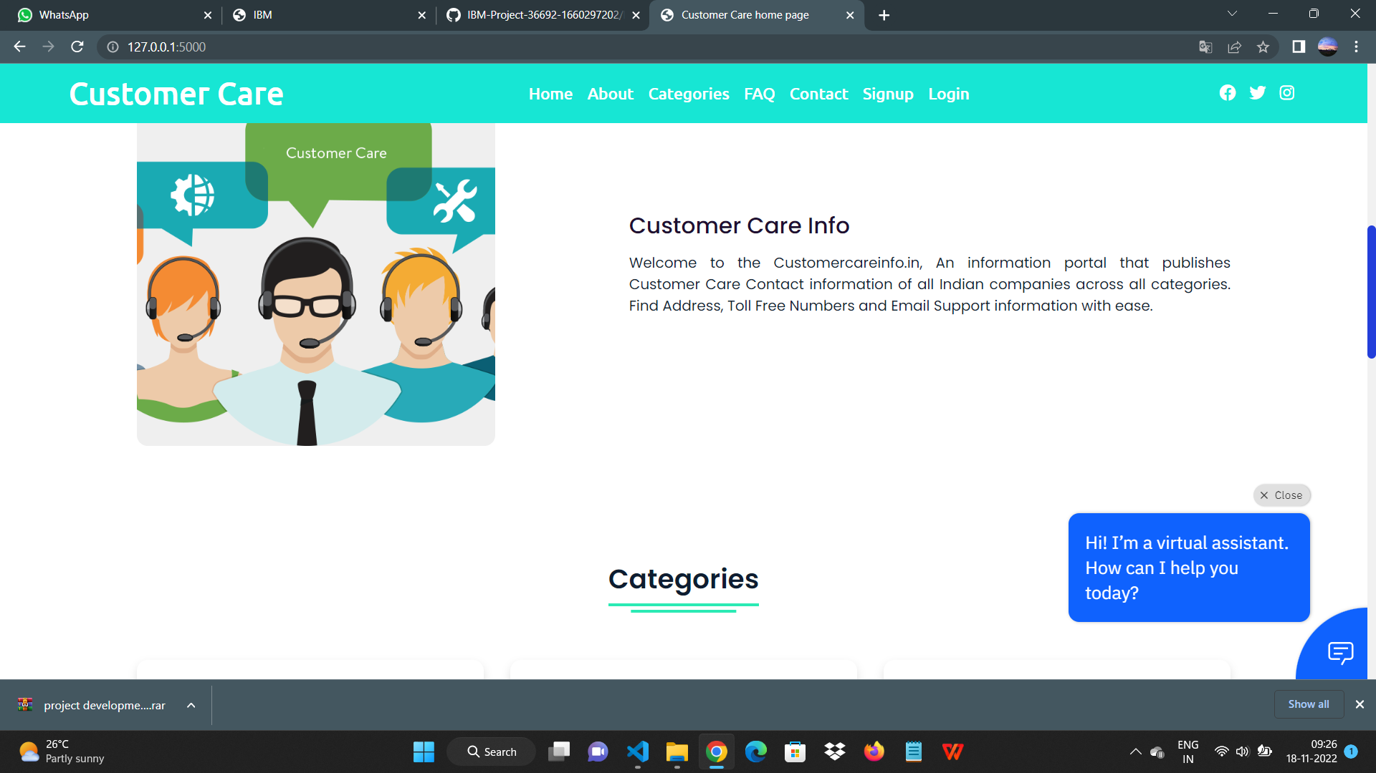

CATEGORIES PAGE:

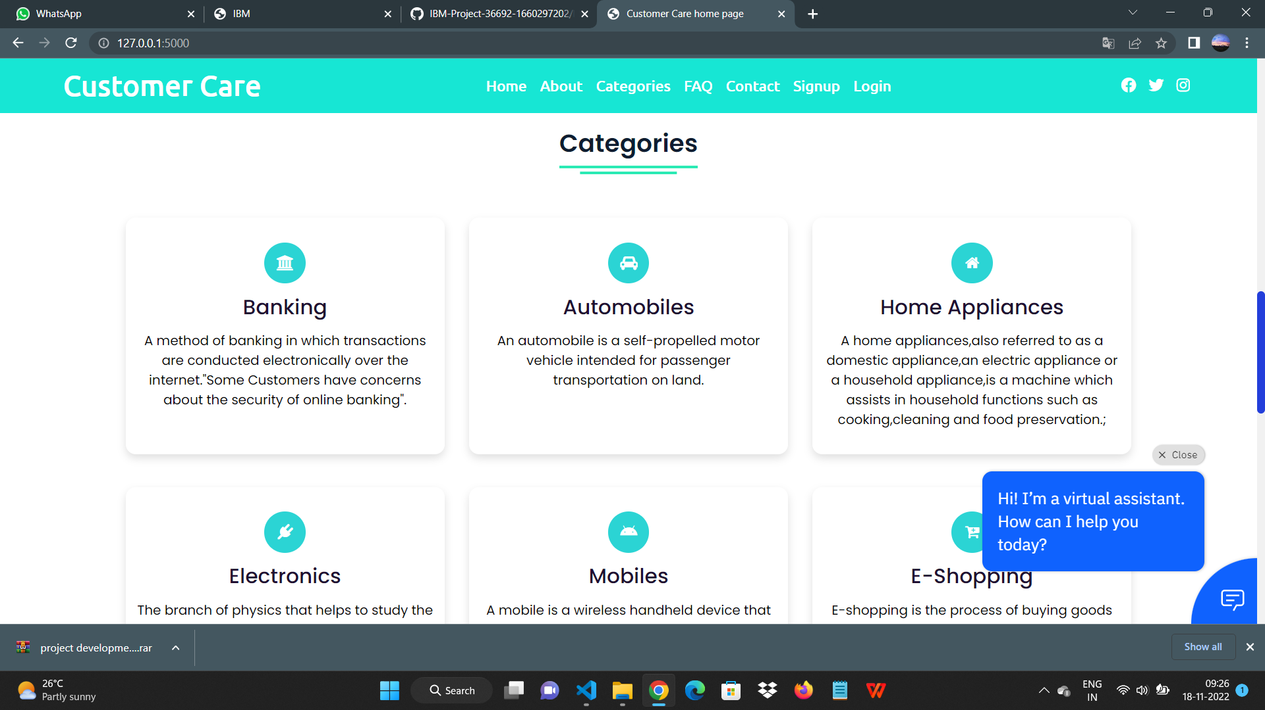

FAQ PAGE:

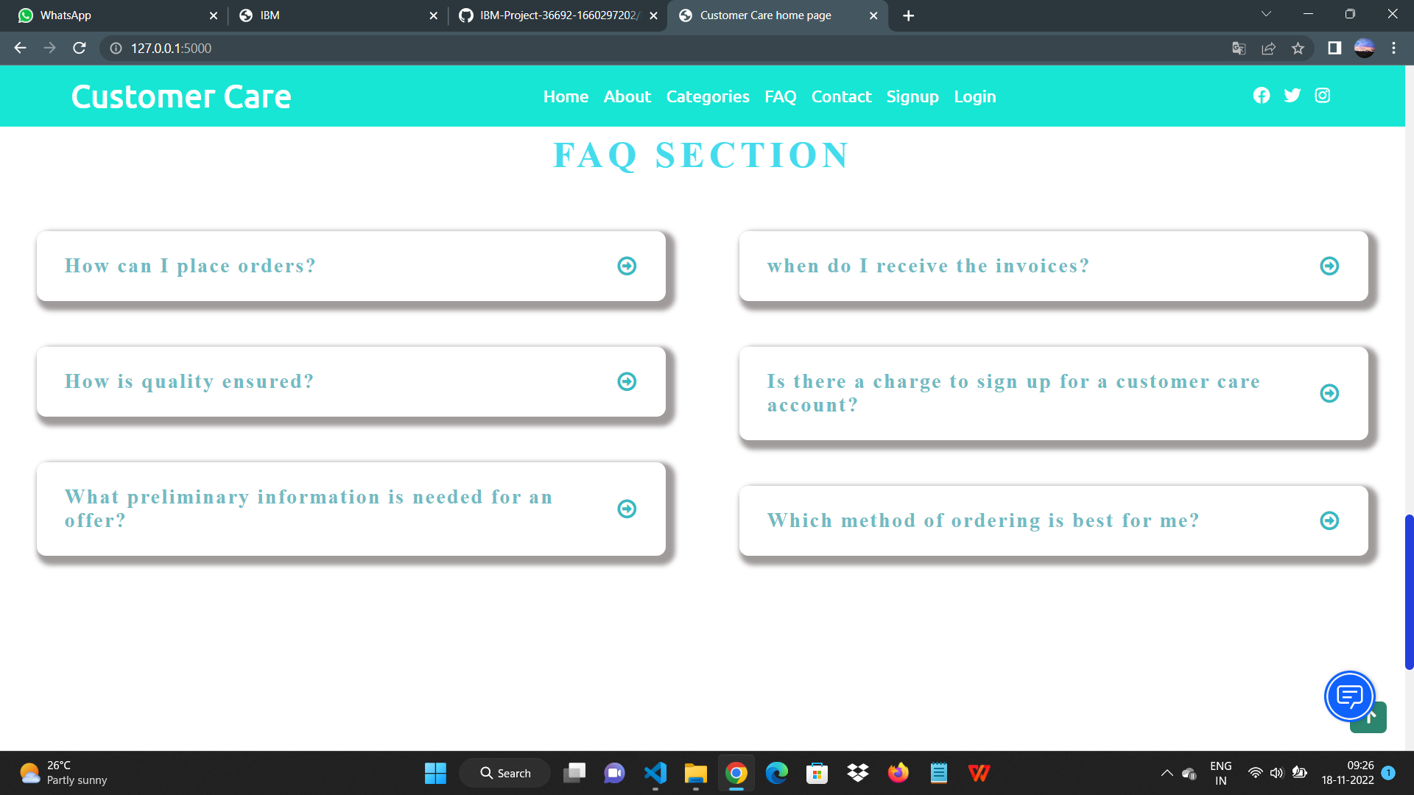

CONTACT PAGE:

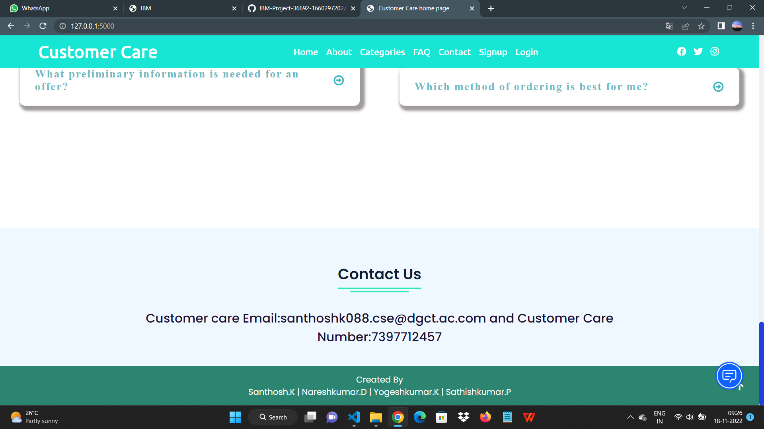

SIGNUP PAGE:

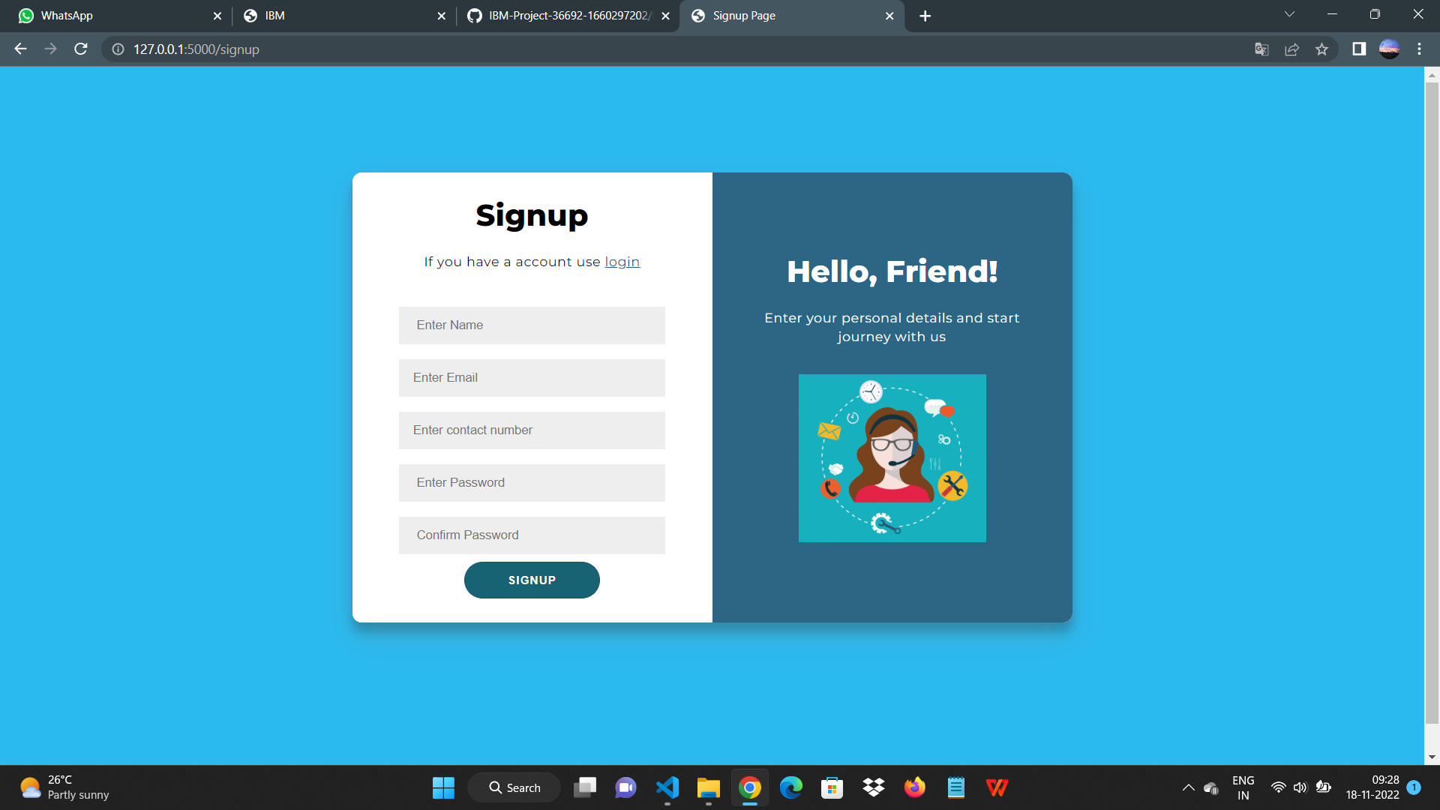

LOGINPAGE**:**

